These are the advertising posters of factories that used to exist in Bermondsey. The posters are now printed on the shutters of the market traders’ stores, near the market in the Blue, off St James’ Road.
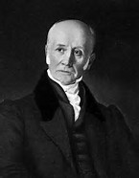
Bryan Donkin & Co.
Bryan Donkin was an eminent inventive genius who solved the problem of preserving food in air-tight containers. In 1819 he opened the world’s first tin canning factory, where Harris Academy School now stands. His invention has become an essential part of everyday life, shaping the way we shop, eat and live.

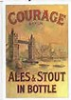
Courage & Co. Ltd.
John Courage began brewing beer in 1787 at Horsleydown and in the following years the brewery expanded to four acres to become one of the country’s best loved brewers with a pub on nearly every street in London. Courage closed in 1981 but the iconic building is still there alongside Tower Bridge.


Crosse and Blackwell
Founded in 1830 the company opened a purpose built factory at Crimscott Street in the early 1920s and became world famous for its vast product range. Most notable was Branston pickle manufactured on site in 1922 until the factory closed in 1969. More than 17million jars are now sold in the UK.
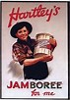
Hartley’s
In 1901 Wilfred “Pickles” Hartley began manufacturing preserves at his factory in Rothsay Street and within a decade was producing nearly 15,000 tons a year. Hartley’s became the largest maker of jam in Europe and a worldwide brand. The “Jam Factory” was converted into apartments after production stopped in the mid-1970s.


Pearce Duff’s
This family-run company opened their Spa Road factory in 1890, being prominent for their custard, blancmange and desserts. By the 1960’s Pearce Duff’s global exports achieved sales in the region of £4 million a year until operations were moved out of the area in 1974 and the factory was closed down.

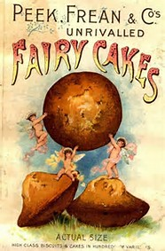
Peek Frean & Co.
The company opened its new factory in Drummond Road in 1873, becoming known locally as Biscuit Town. The first ever chocolate biscuits in 1899, Bourbons, Garibaldi, Cheeselets and so many more classic biscuits were invented by Peek Frean’s. Biscuit Town sadly closed in 1989 after new owners decided to stop UK production.

Pink’s
Established in Staples Street in 1874, by the late nineteenth century the company claimed to be “the largest manufacturer of marmalade in the world” but Pink’s became infamous for poor treatment of its workers, mostly women, who went on strike and inspired the Bermondsey Women’s Uprising, a major landmark in the women’s rights movement.


Sarson’s
In 1814 the Sarson’s vinegar works opened in Tanner Street and became the largest manufacturer of Malt Vinegar in the UK, producing over five million gallons a year at its peak. The pungent smell was distinctive to the surrounding area for almost two centuries until the factory closed in the early 1990s.

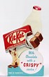
W. Shuttleworth and Co.
Founded in 1881 in Rotherhithe, the company expanded to a new factory in Galleywall Road at the beginning of the 20th century to manufacture chocolate and cocoa products of the highest quality, which they supplied to many famous names in confectionary, most notably Rowntree. Shuttleworths ceased trading in 1973 and the factory closed.
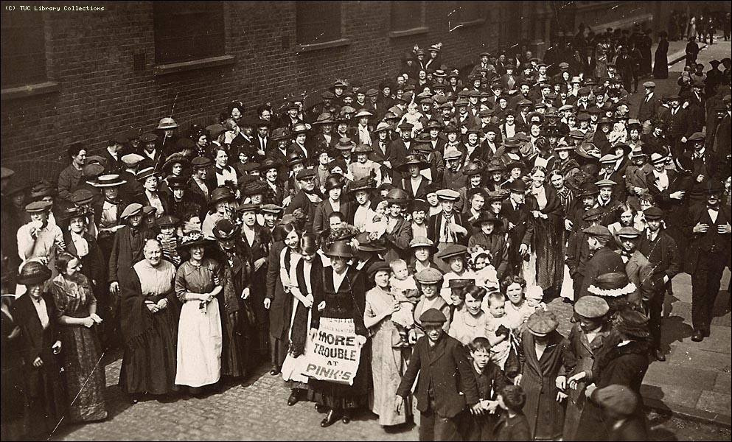
The Bermondsey Women’s Uprising
The “Uprising” began in August 1911, after Bermondsey’s “factory girls” walked out in their thousands following strikes by London dockers. Further inspired by Ada Salter, 15,000 walked to Southwark Park to successfully demonstrate for better pay and conditions. Their actions were crucial in improving the lives of future generations of women workers.

